Assignment Submission 3 Template

In assignment 3, you must repeat all the steps introduced in the assignment description. For each step, you must provide a screenshot to prove it. Insert your screenshot in each step space in this template from Step 3.1.

# Step 3.1 add user “test_yourname”, and check if you successfully added.

I used my last name for this assignment. My last name is Ogertschnig

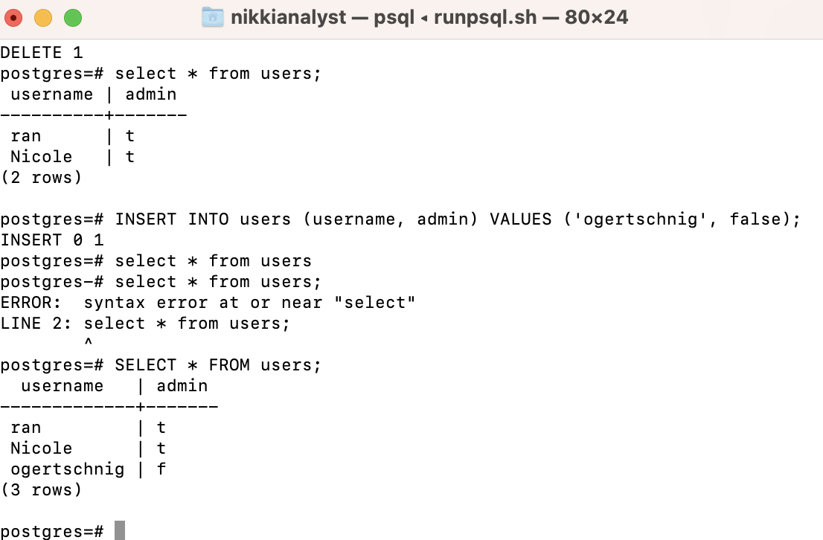

# Step 3.2. Make your is_admin() method safe

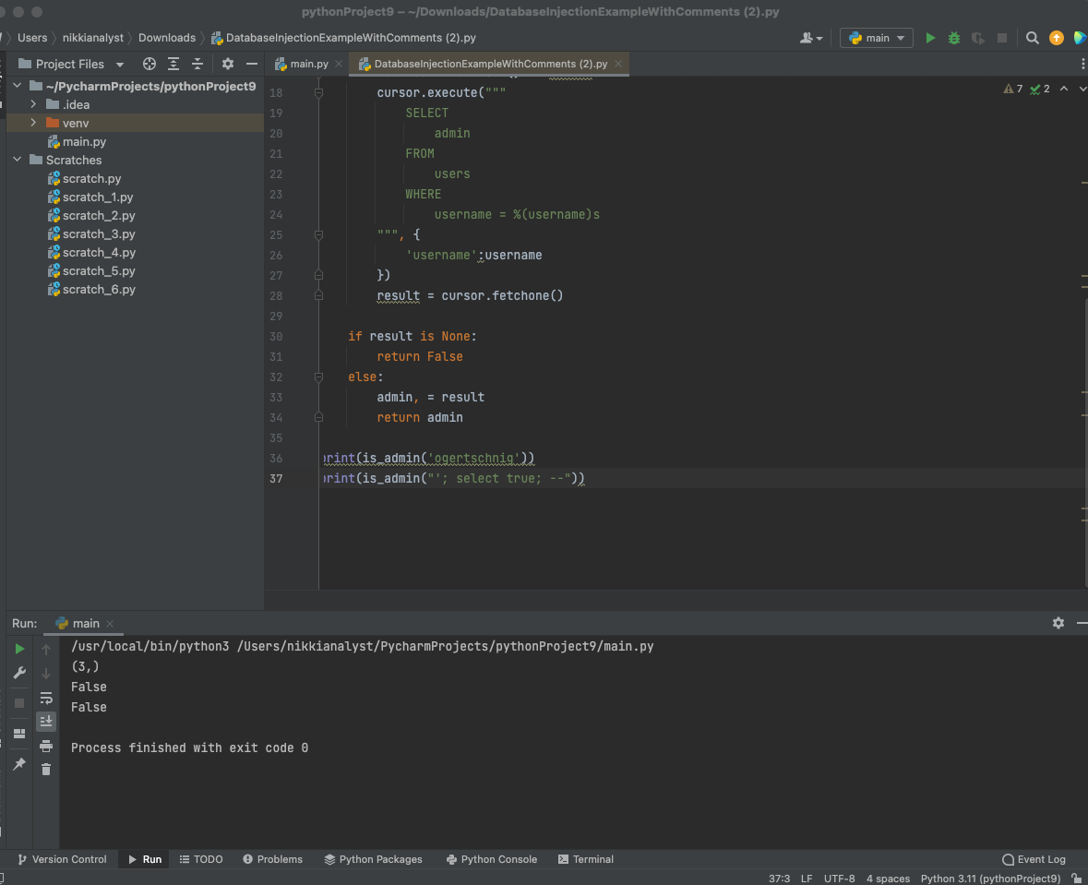

# Step 3.3. Create a secure count_rows() method

[attach your screenshot of all your imported library] (1 point)

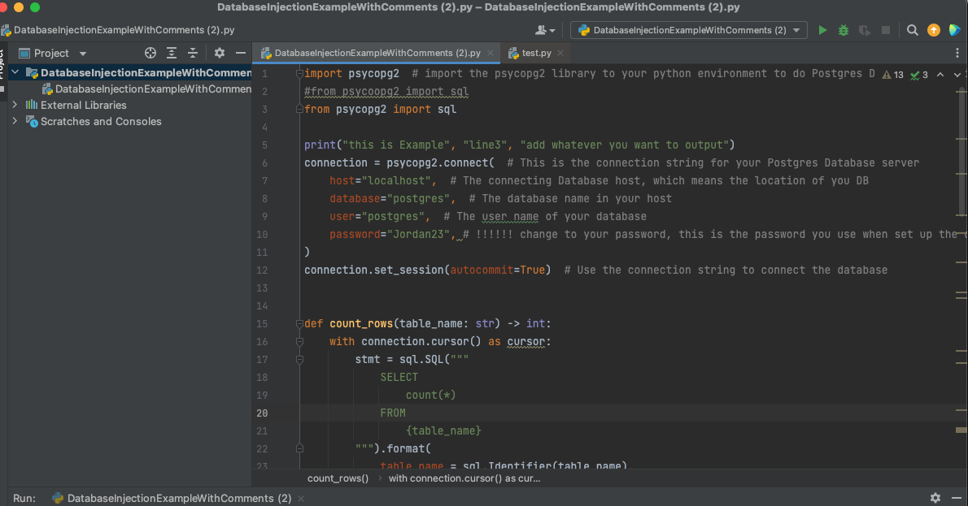

[attach your screenshot of count_rows() method] (2 point)

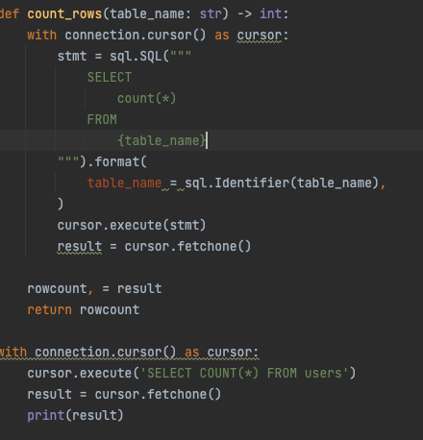

[attach your screenshot for the quires result:

count_rows('users', 1)

count_rows('users', 10)

count_rows("(select 1) as foo; update users set admin = true where name = 'haki'; --", 1)

] (2 points)

